Parent / Carer Survey 2023

Jubilee Parent / Carer Survey 2023
There were 113 responses over a three week period in May 2023. This was in line with the previous year, when 115 responses were received.
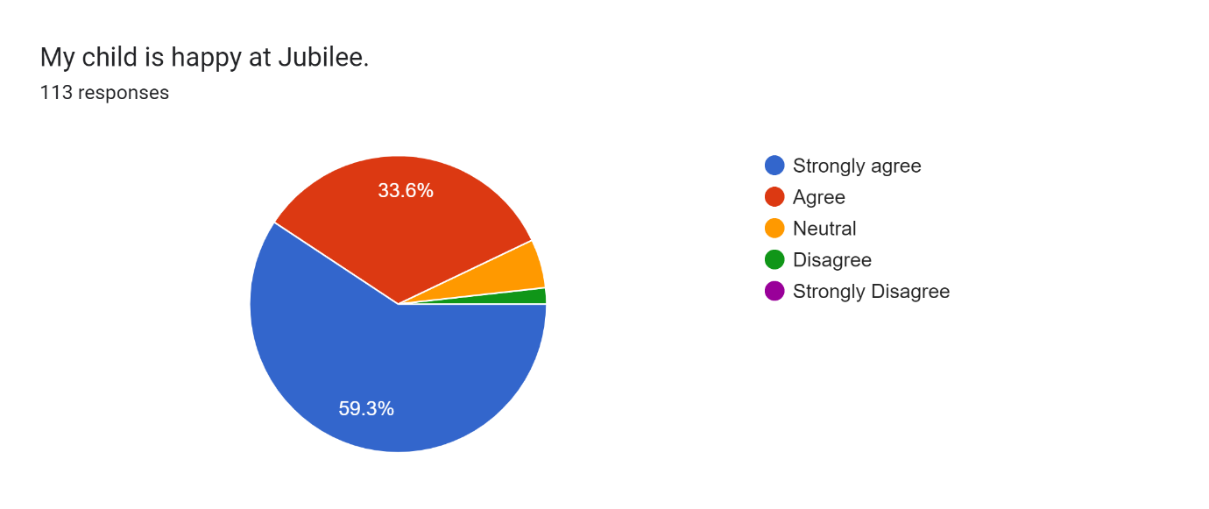

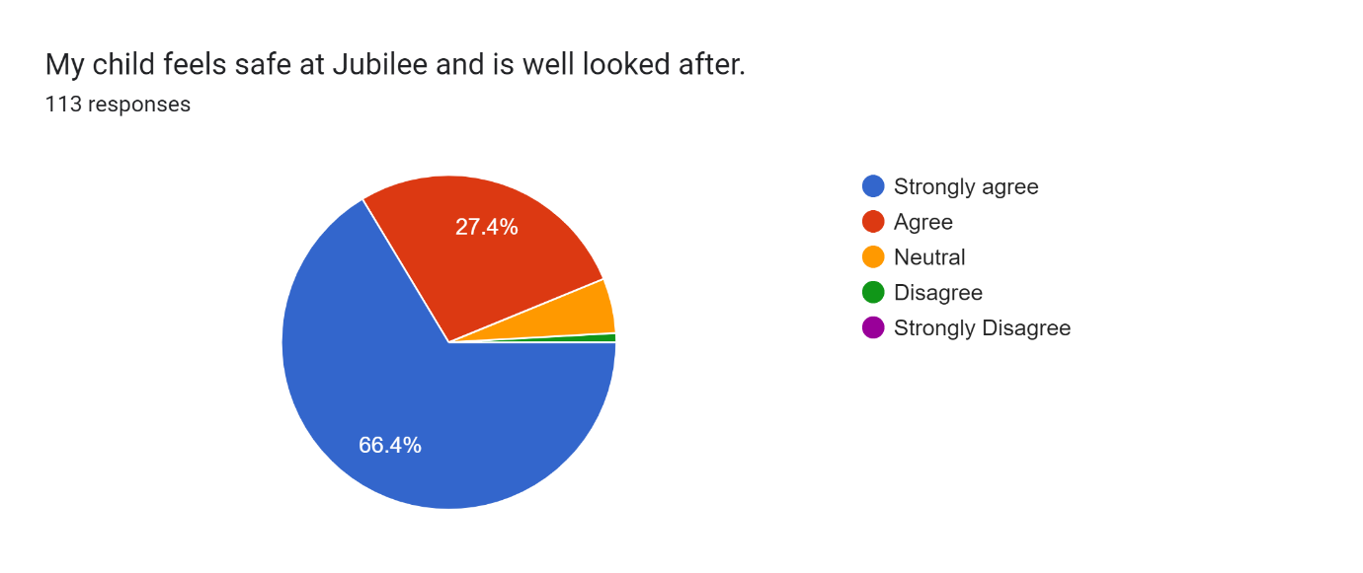

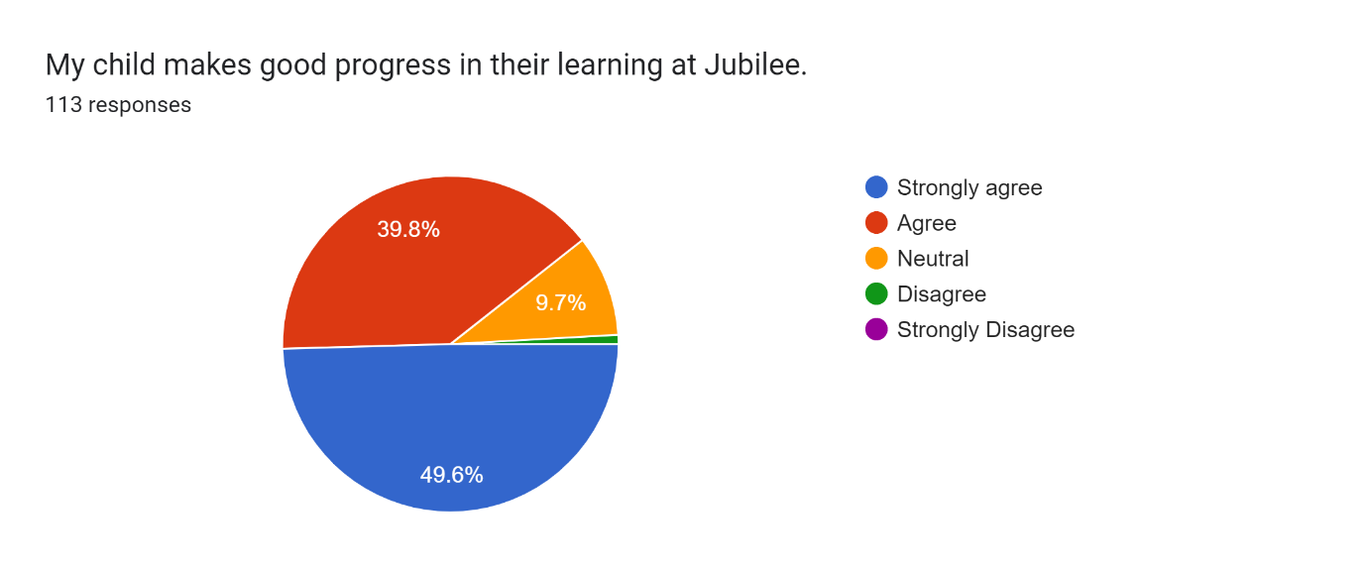

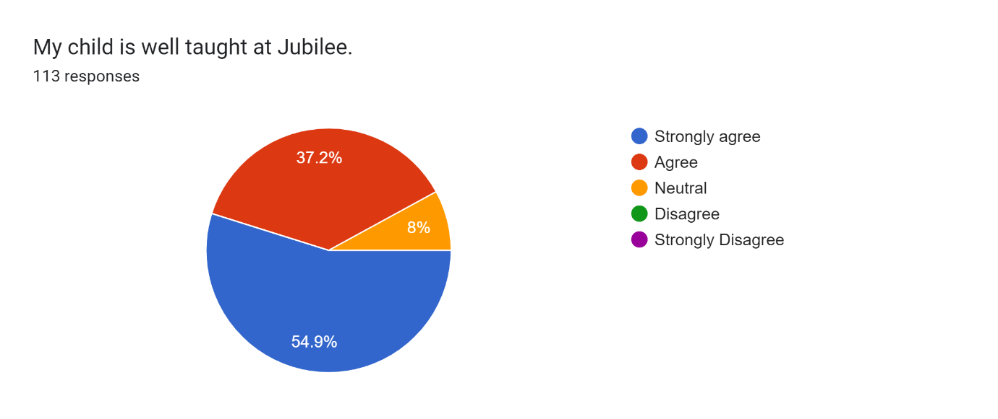

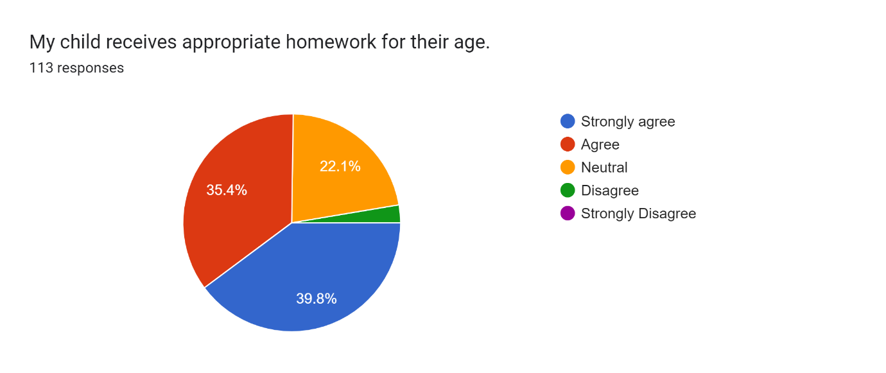

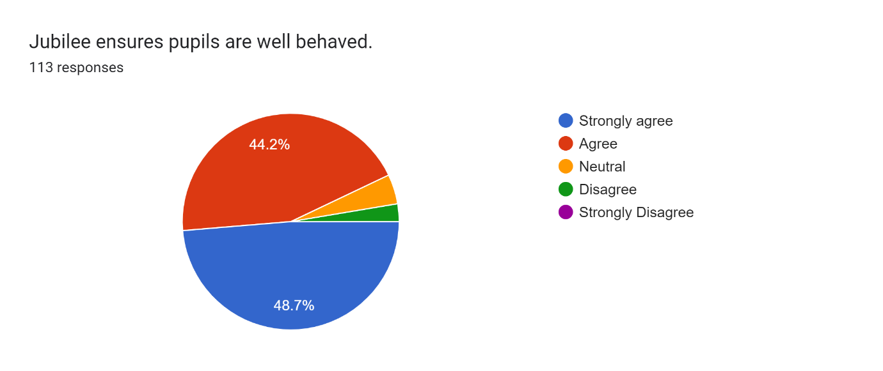

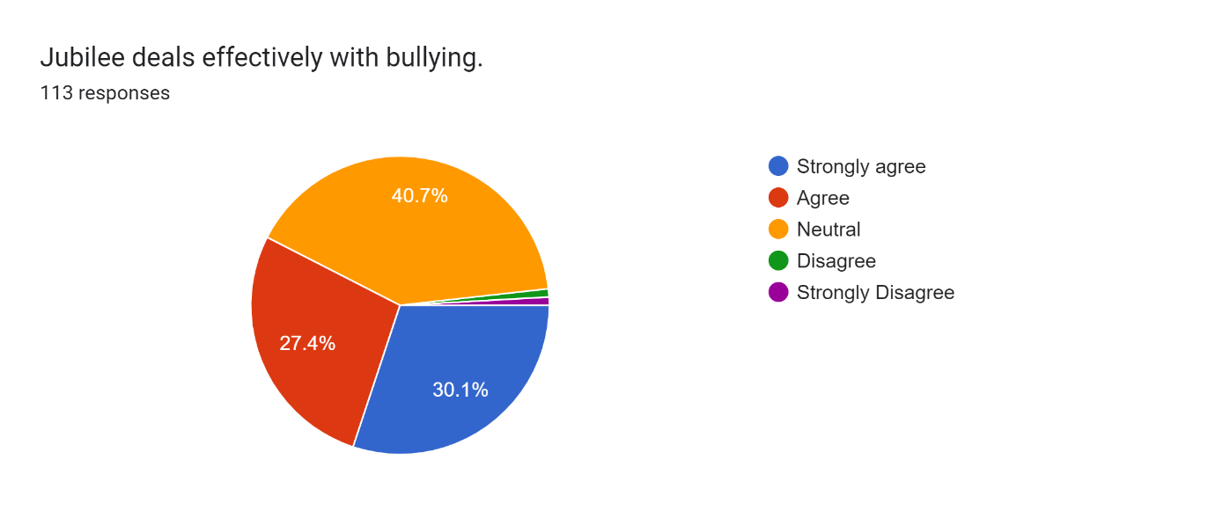

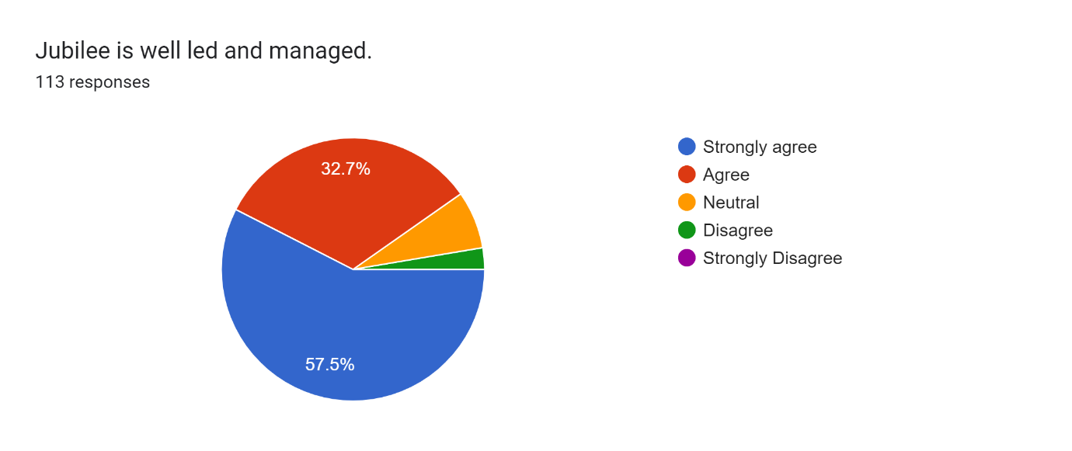

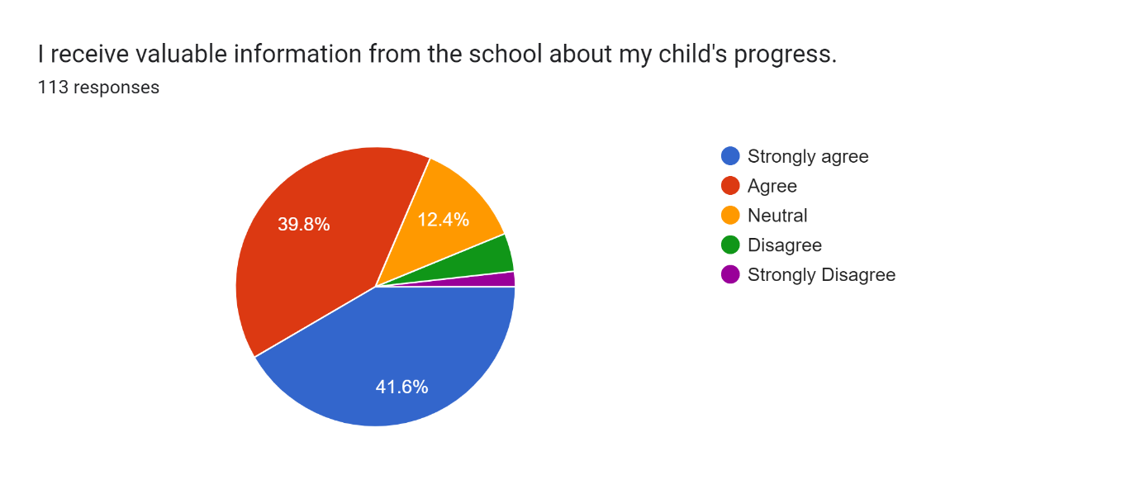

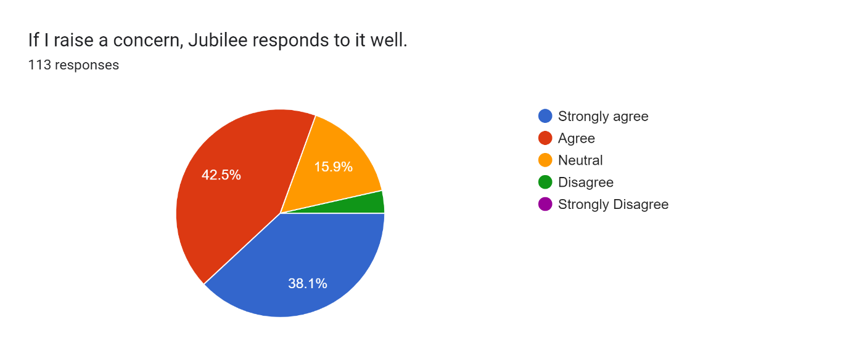

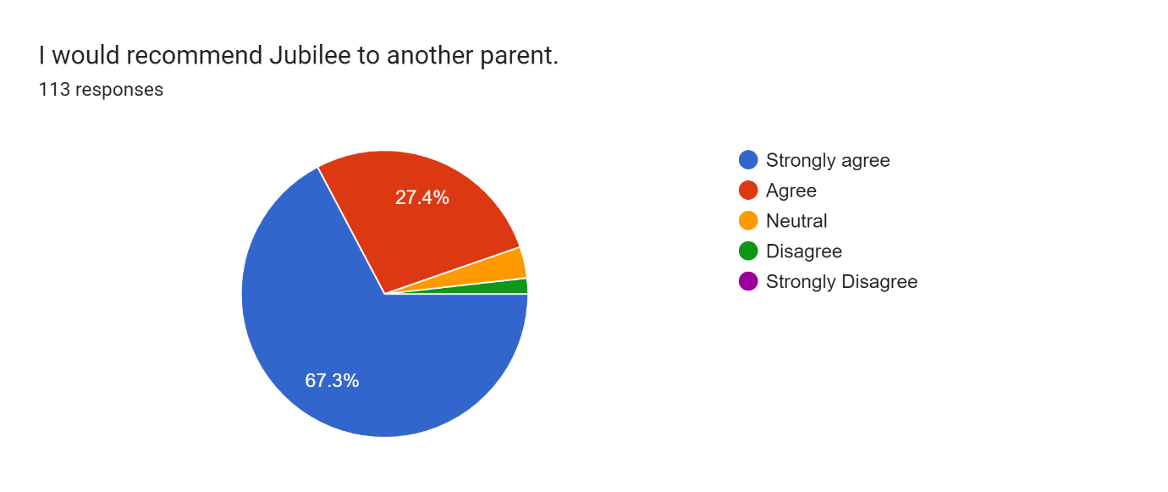

Below is a representative selection of comments from parents and carers:
Amazing support from the teachers especially nursery. I always feel listened to, child is very happy.
My younger child is still struggling to adjust from preschool childcare. I would very different answers for each child. I don't feel the homework works well for my younger child (in reception). My older child would do better if homework was carried out on paper than online.
Keep up the amazing work.
Not had experience of discussing or managing a child being bullied so didn’t feel could count on this.
Great communication between me and the teachers.
I am happy with how much outdoors time the children in the pre-school get. As a mum of 2 boys, I would just encourage the school to create as many PE, forest school and outdoor play opportunities as possible. I think this is central to wellbeing, confidence and physical fitness.
It would be good if more was done for children who feel academically bored, especially in the older years. There does not seem to be sufficient strategy in place to challenge children who are at the top end of academic ability. But the academic activities outside of lessons (sports and art activities) are fantastic.
The school and the teaching is amazing, but the communications are very frequent, but often inaccurate.
A not applicable/don’t know option would be useful for some of these questions. For example not everyone has had experience of bullying.
This is a lovely school. Both my kids are happy, there’s never resistance to the idea of school and any problems or concerns have always been dealt with quickly and fairly. There’s a lot of compassion in the school and teaching team. It feels like a safe place, that is working its hardest to stay creative and interesting and empowering for all our kids, despite everything that’s happening in education. I recommend you all the time, to anyone who will listen. Thank you.
I was slightly concerned about some opinions concerning God/religion that my child expressed they learned at school. As an atheist I’d like to see atheism tonight alongside other belief systems.
With 2 children now having benefited Jubilee’s care and dedication to all children, I can honestly say how incredibly fortunate we have been to be a part of this community
Communication from the school has been poor- it comes from too many different channels and is difficult to keep up with.
Communication with parents could sometimes be improved.
Thank you as always for everything you do that helps our kids and ensures they love school!
Such a lovely school and the children are very happy
I would like a booster class for children who need help and literacy home work to improve their writing and spelling also boost their comprehension.
Jubilee is a fantastic school, thanks to an excellent leadership, staff and community.

